PlanetX:

A Markerless Augmented

Reality App

Test Plan

Prepared by:

Brugada, Jesus Jr. P.

Gloria, Romulus Diego P.

Roguel, Jairus Adrian G.

Ruiz, Angelica Laurene S.

**TABLE OF CONTENTS**

**Table of Contents…………………………………………………………… 1**

**1. Introduction…………………………………………………………….... 2**

1.1 Purpose**…………………………………………………………... 2**

1.2 Scope**……………………………………………………………... 2**

1.3 References**……………………………………………………….. 2**

1.4 Document Terminologies**………………………………………... 3**

**2. Functions/Features to be Tested……………………………………….. 3**

**3. Test Cycle Criteria……………………………………………………….. 4**

3.1 Entry Criteria**…………………………………………………….. 4**

3.2 Exit Criteria**………………………………………………………. 4**

3.3 Continuation Criteria**…………………………………………….. 4**

3.4 Abnormal Termination**…………………………………………... 4**

**4. Milestone………………………………………………………………... 5**

**5. Test Deliverables and Execution………………………………………... 5**

**6. Environmental Needs……………………………………………………. 6**

**7. Planning Risks and Configuration……………………………………….. 7**

**8. Approvals………………………………………………………………... 7**

1. **Introduction**

*PlanetX: Markerless Augmented Reality App* is an application that will help the clients of SMX Convention Center to visualize the events they want to organize with the help of a smartphone camera.

**1.1. Purpose**

The purpose of the system’s test plan is as follows:

■ Identify the features of the app that needs to be tested

■ To gauge the performance of the system

■ To list recommendations for the improvement of the system

■ To show the result of the test activities

■ To ensure that the functionalities and design of the app are implemented and in the demand of the client

**1.2. Scope**

The test plan is solely dedicated for the development team of *PlanetX: A Markerless Augmented Reality App* and no one else. The use cases utilized in the testing process will be coming from the Testlink - an open source test management web application.

**1.3. References**

References used for this test plan is the mock-ups for the simulation of the prototype, the use cases gathered from Testlink, and the Final Paper of their project about the system, as it contains everything the tester needs to know about the system. The knowledge of the team members on the functionalities of their system will be also be significant for the tester to ensure that the system is being tested as intended.

**1.4. Document Terminologies**

|  |  |
| --- | --- |
| **Term** | **Definition** |
| **PlanetX** | The app being tested in this test plan |
| **TP** | Test Plan |
| **UC** | Use Case/s |
| **TC** | Test Case/s |
| **GUI** | Graphical User Interface |

**2. Functions/Features To Be Tested**

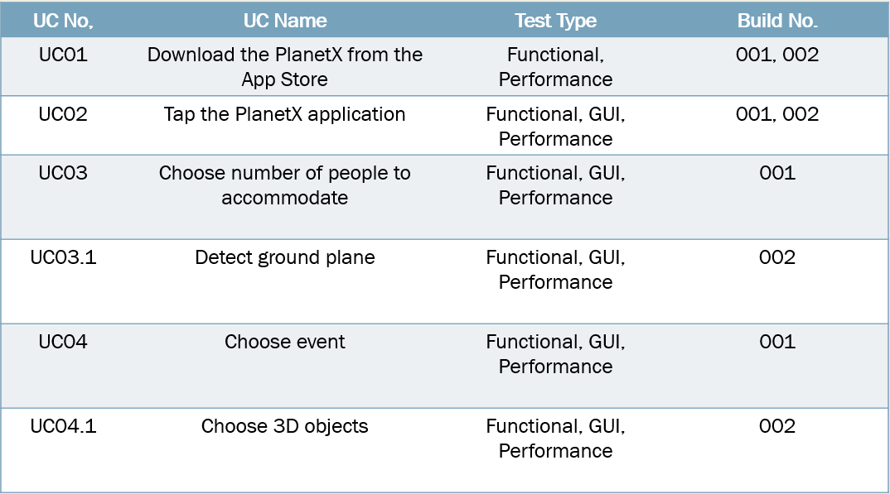

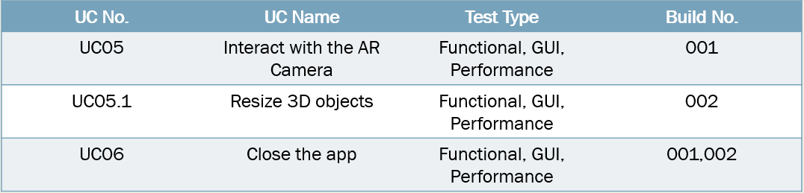

**3. Test Cycle Transition**

**3.1. Entry criteria**

· Requirements are documented, reviewed, and approved (Iteration TP and TC)

· The build is ready for testing

**3.2. Exit criteria**

· TC execution is completed

· No new bugs found after regression testing

**3.3. Continuation Criteria**

· Bugs are fixed or bug status is not in abnormal termination

· PM requests to execute tests

· When there are still test cases up for testing

**3.4. Abnormal Termination**

· Blocker and/or critical bug found that would cause the termination of executing the test (failed in sanity test)

· PM requests to terminate test

· Incomplete deliverables that would waste time to execute test

· Wrong configured environment

**4. Milestone**

|  |  |  |
| --- | --- | --- |
| **Deliverables** | **Date Start** | **Date End** |
| **Develop Test Plan** | February 27, 2017 | March 6, 2017 |
| **Update Test Plan** | March 6, 2017 | March 13, 2017 |
| **BUILD 001** | | |
| **Test Case** | March 13, 2017 | March 13, 2017 |
| **Execute TC - Build 001** | March 16, 2017 | March 16, 2017 |
| **Test Log/Reports** | March 16, 2017 | March 20, 2017 |
| **Review/Update Cases** | March 20, 2017 | March 27, 2017 |
| **BUILD 002** | | |
| **Execute TC - Build 002** | March 27, 2017 | March 30, 2017 |
| **Test Log/Results** | March 30, 2017 | March 30, 2017 |

**5. Test Deliverables and Execution**

1. Key Participants

|  |  |
| --- | --- |
| **Name** | **Role** |
| **Ruiz, Angelica** | Project Manager |
| **Brugada, Jesus** | Quality Assurance Manager |
| **Gloria, Diego** | Quality Assurance Tester |
| **Roguel, Jairus** | Software Designer |

b. Test Reports

Evaluate test results after test case execution in every build of the app; test summary with graphs and status of the bugs to be submitted to Project Manager and to Quality Assurance Analyst.

c. Test Release Management

The test release is within the supervision of the Lead Software Designer/Programmer and the Quality Assurance analyst, a sanity test should be performed for bug prevention.

**6. Environmental Needs**

1. Hardware and Software

|  |  |
| --- | --- |
| **Resource** | **Installed OS/Software** |
| Testing Computer | Windows 10 64-bit  Google Chrome Internet Browser  Testlink |

1. Productivity and Support Tools

|  |  |  |  |
| --- | --- | --- | --- |
| **Tool’s Purpose** | **Tool Name** | **Vendor or in-house** | **Version** |
| Bug Tracking Management | Redmine | Open Source | 3.3.2 |
| Test Management | Testlink | Open Source | 1.9.2 |
| Reports and Documentation | Microsoft Word, Microsoft Powerpoint | Microsoft | 2016 |
| Revision Control System | Github | Open Source | 2.12.2 |

**7. Planning Risks and Configuration**

|  |  |  |
| --- | --- | --- |
| **Risk** | **Mitigation** | **Contingency (When the risk is realized)** |
| When there is shortage in test time | Make the most out the test schedule by efficiently testing use cases | Have more people engaged on testing |
| The test didn’t reflect the use cases | Study the system and the possibility of it going the wrong way | Revise either the use cases or the system |
| Not enough number of use cases | Do a walkthrough of the app and list every functionality | Revise the use cases and do a quick walkthrough |
| Requests for additional updates and features | List every possible added features in the scope for future preference | Make sure that the build is within the scope of the project, or else it should not be changed |

**8. Approvals**

|  |  |  |  |
| --- | --- | --- | --- |
| **Name** | **Role** | **Signature** | **Date** |
| Ruiz, Angelica | Project Manager |  |  |
| Roguel, Jairus | Software Designer |  |  |
| Brugada, Jesus | Quality Assurance Manager |  |  |
| Gloria, Diego | Quality Assurance Analyst |  |  |